**Evalue-2, Qn:16**

**Named function:**

Function a(){

console.log(“a is called”);

}

a();

This way of defining a function is called function statement.

**Function Expression:**

Syntax:

Var b=function(){

console.log(“b is called”);

}

Assigning a function to a variable as values is known as function expression.

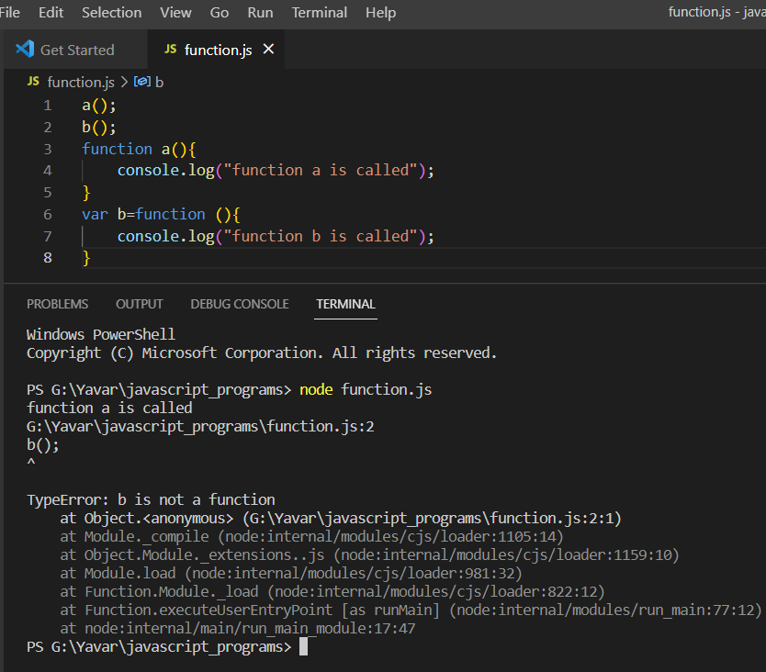

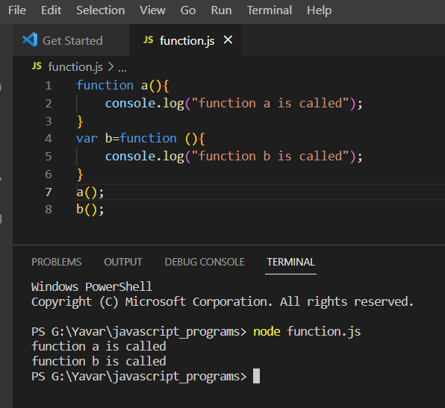

**Note**: The difference between the function statement and the function expression is that a function that is defined as a function can be hoisted but a function that is assigned as values to variables i.e a function expression cannot be hoisted.